# Haptic Feedback VR Gloves

By

Fname Lname

Master Project Thesis

This thesis is submitted in partial fulfillment of the requirements for the Master of Science degree in Electrical Engineering, with a specialization in Virtual Reality and Haptic Technologies.

Cal Poly Pomona – College of Engineering

Prof. Name

Dec 6th, 2023

# Abstract

The document is a master’s thesis project focused on the development of innovative haptic VR gloves. The study aims to enhance the virtual reality experience by designing gloves that accurately track finger movements and provide tactile feedback when interacting with virtual objects. Emphasis is placed on using cost-effective, easily accessible materials for broader adoption. The research covers the history of haptic technology, current technologies, and a comparative analysis of existing products. Methodology includes software and hardware development, addressing challenges, and providing technical analysis. Applications in gaming, education, and medical fields are explored, alongside future directions for the technology.

**Table of Contents**

1. Introduction 1

1.1 Background Information: 1

1.2 Thesis Statement: 1

1.3 Scope of Research: 2

2. Literature Review: 3

2.1 Historical Development: 3

2.2 Current Technologies: 4

3. Methodology: 7

3.1 Project Overview: 7

3.2 Software Development: 7

3.3 Hardware Development: 8

3.4 Challenges and Problem-Solving: 12

4. Technical Analysis: 15

4.1 Software Architecture: 15

4.2 Haptic Feedback Mechanism: 17

4.3 Finger Tracking Mechanism: 19

5. Application and Use Cases: 22

5.1. Gaming and Entertainment: 22

5.2. Education and Training: 22

5.3. Medical and Rehabilitation: 23

7. Future Directions: 24

7.1. Emerging Technologies: 24

7.2. Potential Innovations: 24

8. Conclusion: 26

8.1 Summary: 26

8.2. Implications: 26

8.3. Final Thoughts: 27

References: 28

Appendix A: – Assembly Pictures 29

Appendix B: Result Picture. 32

# 1. Introduction

## 1.1 Background Information:

In recent years, Virtual Reality (VR) has emerged as a transformative technology in various fields, ranging from entertainment to education and beyond. At its core, VR creates immersive digital environments that simulate real or imagined settings, providing users with a sensory experience that mimics physical presence. Integral to enhancing this immersive experience is haptic technology, which aims to recreate the sense of touch by applying forces, vibrations, or motions to the user. Haptic feedback in VR allows users to 'feel' digital objects and environments, significantly enriching the user experience. By integrating haptic feedback into VR devices, such as gloves, the line between the virtual and the real continues to blur, offering a more authentic and engaging experience.

## 1.2 Thesis Statement:

The primary objective of this study is to design and develop innovative haptic VR gloves that not only track the location of each finger to simulate hand movements in the VR world but also provide tactile feedback upon interacting with virtual objects, particularly when grasped in the palm. A key focus of this development is the use of materials that are both cost-effective and easily accessible, aiming to create a product that is feasible for wider adoption and use. This approach ensures that the advanced capabilities of haptic VR gloves become more accessible to a broader audience, potentially revolutionizing the way users interact with virtual environments.

## 1.3 Scope of Research:

This research concentrates on two main aspects: first, the development of a precise and responsive finger-tracking mechanism to accurately simulate hand movements in a virtual space. This involves intricate sensor integration and software development to ensure fluid and natural hand motion replication. Second, the study explores the design of minimal yet effective haptic feedback systems, specifically focused on sensations encountered when a virtual object is held in the palm. This feedback is crucial for enhancing user engagement and realism in VR experiences. Additionally, considerable attention is given to the design aspects of the gloves, prioritizing ease of assembly and potential for mass production. By addressing these specific areas, the research aims to contribute significantly to the field of VR, pushing the boundaries of user interaction within virtual environments.

# 2. Literature Review:

## 2.1 Historical Development:

The evolution of haptic technology in the context of virtual reality (VR) is a journey marked by innovation and progress. This section will detail the chronological development of haptic technology, highlighting key milestones that have shaped its integration into VR.

* 1960s and 1970s - Early Beginnings: The roots of haptic technology can be traced back to this era when engineers and scientists began creating mechanical buttons and switches that provided physical feedback. These devices, based on simple mechanical interactions like the click of a switch or the vibration of a motor, were initially used in aerospace and defense for operations requiring tactile feedback​​.
* 1980s and 1990s - Advancements in Sensory Feedback: During these decades, haptic technology evolved to offer more complex and nuanced sensory feedback. This period saw the development of devices capable of force feedback, enabling users to physically interact with virtual objects in a realistic manner. Additionally, pressure-sensitive technologies emerged, allowing users to experience varying intensities of touch and the texture of objects in virtual environments​​.
* Late 2000s - Miniaturization and Integration in Consumer Electronics: As haptic devices became smaller and more compact, they found their way into a broader array of devices, notably smartphones and gaming controllers. Most smartphones began incorporating haptic feedback systems, providing users with sensory feedback for touch-based interactions. This integration marked a significant milestone in making haptic technology a commonplace feature in consumer electronics​​.
* Wearable Haptic Devices: The development of wearable haptic devices like smartwatches and fitness trackers represented a significant leap in the application of haptic technology. These devices utilized haptic feedback for real-time notifications and alerts, enhancing user connectivity and introducing new applications in healthcare and rehabilitation​​.
* Integration in VR/AR Systems: One of the most transformative developments has been the integration of haptic feedback into VR and augmented reality (AR) systems. In these environments, haptic devices simulate the sensation of touching and interacting with virtual objects, greatly enhancing the immersion and realism of virtual experiences. This integration has fundamentally changed how users explore and interact with digital environments​​.
* Challenges and Ongoing Developments: Despite these advancements, the development of haptic feedback systems that can fully replicate real-world touch remains a challenge. Innovations in materials and technology continue to advance the field, striving to create devices that are lightweight, compact, and capable of delivering a range of sensory experiences akin to natural touch​​.

The historical development of haptic technology in VR reflects a trajectory of rapid innovation and expanding applications. From its early mechanical origins to its current state as an integral part of immersive VR experiences, haptic technology continues to evolve, promising to add new dimensions to our interactions with digital worlds.

## 2.2 Current Technologies:

In this section, we will review two prominent haptic VR glove products: HaptX Gloves and Manus Prime 3 Haptic XR, focusing on their technology, mechanisms, user experience, and applications.

### HaptX Gloves

Technology and Mechanisms:

* Microfluidic Actuators: HaptX Gloves use patented microfluid-based haptics instead of traditional motor-based feedback. They employ hydraulics and microscopic concentrations of liquid in smart textiles with tiny channels. These channels control the glove’s 130 embedded tactile actuators, creating air bubbles that push against the user’s skin to represent texture, hardness, or softness​​.
* Force Feedback: For solid virtual objects, HaptX Gloves incorporate force feedback. They use an exoskeletal hand that provides resistance (up to 4 lbs.) to prevent the user's hand movements from piercing through virtual objects. This requires intricate tracking hardware and software to respond accurately to the user's interactions with virtual objects, including aerial ones​​.
* Magnetic Motion Tracking: The gloves feature sub-millimeters accuracy hand tracking with six degrees of freedom per finger, using proprietary software and electronics. This technology automatically generates a virtual hand avatar, requiring no additional coding to map the hand in virtual space​​.

User Experience and Applications:

* HaptX Gloves provide a highly immersive VR experience, allowing users to realistically feel the shape, movement, texture, and weight of virtual objects. Their applications span various fields, including automotive design, where they are used in virtual workshop simulations, enhancing realism and aiding in design and manufacturing processes​​.

### Manus Prime 3 Haptic XR

Technology and Mechanisms:

* High Fidelity Hand Tracking: The Manus Prime 3 Gloves continue tracking beyond the limits of optical field of view, ensuring uninterrupted hand tracking​​.
* Integrated Haptics: These gloves are designed for comfort and unobtrusiveness, allowing a full range of motion without breaking immersion. This integration is key for maintaining a realistic experience​​.
* Prop Tracking: The gloves enable precise tracking of props, allowing users to feel the objects they are interacting with in VR, further enhancing the tactile experience​​.

User Experience and Applications:

* Training and Skill Development: The Manus Prime 3 Haptic XR gloves are used in immersive training environments. They enable efficient skill development by providing multisensory feedback and enhancing the learning process​​.
* Design and Prototyping: These gloves streamline the design process by providing a realistic sense of objects without the need for physical prototypes. This allows early validation of designs through human interaction, saving time and costs​​.

Both HaptX Gloves and Manus Prime 3 Haptic XR represent the cutting edge of haptic VR technology, each offering unique features and applications. HaptX focuses on detailed tactile feedback and force resistance, while Manus Prime 3 emphasizes high-fidelity tracking and practical applications in training and design. The choice between them would depend on specific needs, such as the level of tactile detail required or the particular use case in training or design simulation.

# 3. Methodology:

## 3.1 Project Overview:

This project focuses on the development of advanced haptic VR gloves designed to enhance the virtual reality experience by enabling detailed finger tracking and providing tactile feedback. The primary goal is to create an immersive interface where users can interact with virtual environments in a more natural and intuitive manner. This is particularly aimed at enriching VR applications in gaming, educational simulations, and medical training.

The project employs a combination of hardware and software tools to achieve a seamless integration of the gloves with virtual reality systems, ensuring functionality and user engagement.

## 3.2 Software Development:

### Software Utilized:

* Steam/SteamVR: Serving as the primary testing and operational platform, SteamVR allows for evaluating the gloves’ performance in various VR scenarios.
* Oculus Desktop App: This software connects the Oculus Quest 2 headset to the desktop, ensuring compatibility and smooth operation within the VR ecosystem.
* OpenGloves: A key component in the development process, OpenGloves provides necessary drivers for interfacing the gloves with SteamVR. It also offers a demo for testing and refining the gloves' haptic feedback.

### Programming Tools and Libraries:

* Arduino IDE: The microcontroller programming, particularly for the ESP32 used in the gloves, is conducted through the Arduino IDE. This environment facilitates the implementation of software controlling the gloves' haptic feedback and finger tracking mechanisms.
* The Silabs CP210x USB to UART chip library, which was used for establishing a stable communication link between the gloves and the computer.
* The ESP32 package provided the foundational codebase for operating the ESP32.
* The ESP32Servo library, specifically utilized for controlling the servo motors responsible for haptic feedback. This library allowed precise manipulation of the servos to simulate various tactile sensations.

In summary, the integration of Oculus Quest 2's hand tracking with custom VR gloves for finger tracking, when combined with the aforementioned software and programming tools, creates a synergistic effect. This enhances the VR experience by bringing a higher level of realism and precision to user interactions in virtual environments.

## 3.3 Hardware Development:

### Hardware Components:

* Oculus Quest 2: This advanced VR headset is used as the primary interface for the VR environment. The Oculus Quest 2, along with its controllers, provides robust hand tracking capabilities. The controllers' role is to track the position and orientation of the hands in the VR space, laying the foundation for the immersive experience.
* Custom Haptic VR Gloves: The gloves are designed to complement the Oculus Quest 2 by providing precise finger tracking. This functionality allows for detailed and responsive interactions within the VR environment, going beyond the capabilities of the Oculus controllers alone. The gloves are equipped with potentiometers to track finger movements and provide haptic feedback, respectively.

### Gloves Component List

#### Table 1: Electrical Components

|  |  |  |
| --- | --- | --- |
| Part | Quantity | Use |
| ESP32 WROOM Dev Board | 1 | Main Controller for sensors and motors |
| 10k ohm Potentiometer | 5 | For Finger Tracking |
| 9g servo motors | 5 | For Haptic Feed-Back |
| Dupont wires |  | For connections |

#### Table 2: 3d Printed Components

|  |  |  |
| --- | --- | --- |
| Part | Quantity |  |
| HapticSpool | 5 | The String will attach to the spool and connect to the tensioner, when the spool is rotated the potentiometer will turn as well |
| SpoolCover | 5 | Will cover the haptic spool to help reduce tangling |
| Tensioner | 5 | Will hold the potentiometer and the spring and connect to the potholder |
| Potholder | 5 | The potholder will hold the spool module and attach it to the rigid mount. It will also hold the servo motos. This is the main Haptic feedback module |
| End Cap | 5 | Placed at the end of the finger and attached to the end of the string, will pull the haptic spool when finger is closer |
| Guide Node | 16 | Will guide the string from the haptic spool to the end cap |
| Rigid Mount | 1 | Will hold the haptic feedback modules on top of the glove |
| Quest2_MountSlider | 1 | Attaches the Quest controller to the gloves |

#### Table 3: Other Components

|  |  |  |
| --- | --- | --- |
| Part | Quantity | Use |
| Badge Reels | 5 | For the rotary springs |
| Work Gloves | 1 | Main frame to hold all components |
| Velcro strap |  | To secure haptic modules |

### Assembly Process:

1. **Assembling the Spools:**
   1. Each glove requires five spools, one for each finger.
   2. Start by inserting a potentiometer into the bottom of the tensioner. It should screw in place.
   3. Attach a string to the Haptic spool.
   4. Insert this Haptic spool, now connected to the string, onto the potentiometer.
   5. Finally, place the spool cover onto the tensioner. It should click securely into place.
2. **Assembling the Haptic Feedback Modules:**
   1. Insert the potentiometer into its designated holder.
   2. Use pliers to remove the metal loops from the ends of the badge reels.
   3. Secure these metal loops to the plastic loops on the holders.
3. **Setting up the rigid mount:**
   1. Begin by applying a layer of foam to the bottom of the rigid mount for comfort.
   2. Optionally, use the two circular holes on the mount to add an elastic loop. This loop will sit in front of the thumb for better fit and stability.
   3. Attach a Velcro strap between the two loops of the rigid mount. Trim the strap for a comfortable fit around your hand.
   4. Once mounted on your hand, slide the assembled modules onto the rigid mount. Depending on your hand size, some modules might need to be slid on backward to ensure proper string alignment.
4. **Gluing up the nodes and caps:**
   1. Glue the end caps to the tips of each finger.
   2. Next, glue the guide nodes along each finger. Positioning these nodes adjacent to or directly over the knuckles will provide the best angle for the string to move in sync with finger movements.
5. **Adding Haptics:**
   1. Place the servo motors into their respective slots in each assembly.
   2. Attach a single-direction servo head onto the gear of each motor.
   3. Adjust the orientation of each servo head through trial and error to find the optimal rotation for effective haptic feedback.

After completing these assembly steps, you can refer to Appendix A for pictures of the final product. These images will give you a clear visual representation of how the assembled haptic VR gloves should look.

### Wiring Diagrams:

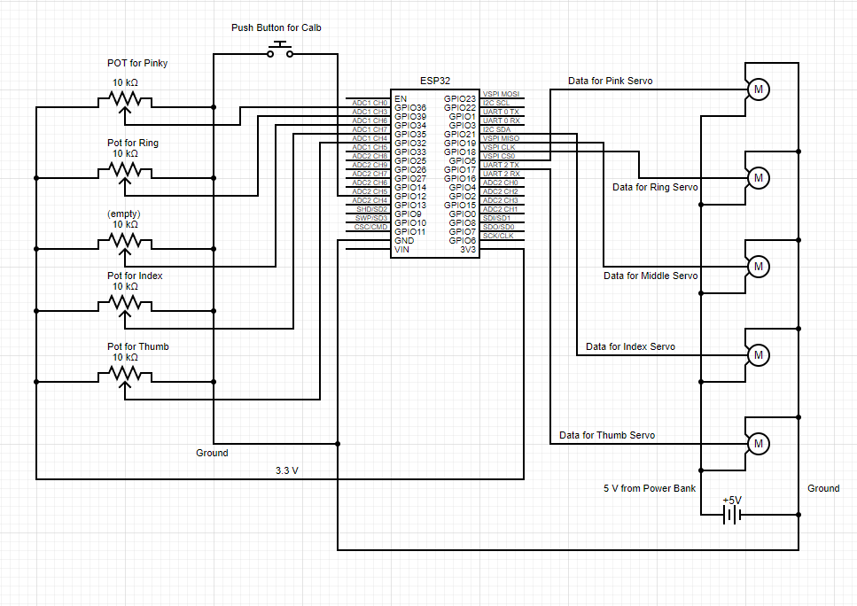

## 3.4 Challenges and Problem-Solving:

### Hardware Integration Challenges

Sensor Accuracy and Consistency: One significant challenge was ensuring accurate and consistent readings from the finger-tracking sensors. Variations in sensor output due to environmental factors or hardware inconsistencies posed a problem for reliable tracking.

Solution: Implemented a calibration routine at the start of each session. Adjusted the sensor placement and sensitivity to minimize external interference and enhance consistency.

Servo Motor Control: Achieving precise control of the servo motors for realistic haptic feedback was challenging. The motors needed to respond accurately to varied virtual environments.

Solution: Refined the control algorithms for the servo motors. Conducted extensive testing with different haptic patterns to ensure responsiveness and realism.

### Software Development Challenges

Integration with SteamVR and Oculus: Ensuring seamless integration with SteamVR and Oculus systems was complex, particularly regarding compatibility and communication protocols.

Solution: Utilized the OpenGloves software as a bridge. Worked on customizing the drivers and tweaking settings to ensure smooth communication between the gloves, SteamVR, and the Oculus Quest 2.

Latency in Data Transmission: Initial prototypes exhibited noticeable latency in transmitting sensor data from the gloves to the VR system, impacting user experience.

Solution: Optimized the data transmission code for efficiency. Switched to a more efficient serialization method to reduce lag.

### Mechanical Design Challenges

Ergonomics and Wearability: Designing the gloves to be comfortable and ergonomic for prolonged use was a challenge, especially when integrating electronic components without hindering natural hand movements.

Solution: Iterative design process with user feedback. Adjusted the layout of components and used flexible materials for parts of the gloves to enhance comfort.

Durability and Maintenance: Ensuring the gloves were durable and easy to maintain, especially with repeated use, was a concern.

Solution: Selected robust materials for construction. Designed the gloves with modular components for easy replacement and maintenance.

# 4. Technical Analysis:

## 4.1 Software Architecture:

The software architecture of the VR glove system is a structured framework designed to manage and facilitate interaction between various hardware components (sensors, actuators, and microcontroller) and software modules. This architecture is critical for ensuring that the glove accurately tracks finger movements and provides realistic haptic feedback in a virtual reality environment.

### Hardware Interaction

* Microcontroller (ESP32): The central processing unit of the system, responsible for coordinating the activities of various sensors and actuators. It runs the firmware, which is the primary software component of the glove.
* Sensors (Analog Inputs): Attached to each finger, potentiometers detect the degree of bend or flexion in the fingers. The microcontroller reads these analog signals and converts them to digital values for processing.
* Actuators (Servo Motors): Used for haptic feedback, servo motors are controlled by the microcontroller through PWM signals. They physically react to the virtual environment's stimuli, providing a tactile sensation to the user.
* Additional Inputs/Outputs: Include buttons for calibration and LEDs for status indication or debugging, interfaced with the microcontroller.

### Software Components

* Configuration and Definitions: This part of the code defines system-wide settings and constants, such as communication protocols, sensor configurations, and servo motor settings. These definitions allow for customization and flexibility in the system's setup.
* Communication Interface: The software includes modules for handling data transmission between the glove and external devices (like a VR system or computer). This could be through serial communication over USB or Bluetooth. The communication module is responsible for encoding and decoding data packets and ensuring reliable data exchange.
* Sensor Data Acquisition and Processing: This module deals with reading the analog sensor data, applying noise reduction techniques like median filtering, and calibrating the sensor data to ensure accurate tracking of finger movements.
* Haptic Feedback Control: A crucial module that interprets the incoming data from the VR environment and translates it into specific servo motor movements. This module is responsible for providing tactile feedback that mimics real-world interactions.
* Main Control Loop: This is the central part of the firmware that orchestrates the operation of the system. It continuously runs, reading sensor data, processing it, sending and receiving data to and from the VR system, and updating the servo motors based on the received inputs.
* Utility Functions: These include functions for specific tasks like reading button states, scaling servo motor values, and other helper functions that support the primary operations of the glove.

### Interaction Flow

The software architecture is designed to facilitate a seamless flow of information and control commands across the system. When the glove is in operation, the main loop continuously reads data from the finger sensors. This data is processed and calibrated to accurately reflect finger positions. Simultaneously, the system may receive data from the VR environment (via the communication module), which is then used to control the servo motors, providing haptic feedback. The continuous and rapid execution of these tasks ensures a responsive and immersive VR experience.

The software architecture of the VR glove system effectively integrates hardware and software components. It ensures accurate finger tracking and realistic haptic feedback, essential for an immersive virtual reality experience. This architecture highlights the importance of efficient data processing, reliable communication, and precise control of hardware elements in interactive VR systems.

## 4.2 Haptic Feedback Mechanism:

The core of the haptic feedback mechanism lies in the function *writeServoHaptics*, which is responsible for controlling the servo motors based on the received interaction data. Here's a key excerpt from the code:

In this function, hapticLimits is an array that holds the interaction data for each finger, received from the VR environment. This data determines the extent to which each servo should move.

The call to scaleLimits(hapticLimits, scaledLimits) is particularly crucial. It's responsible for converting the raw interaction data into servo positions.

scaleLimits function:

This function performs a linear mapping of the received interaction values to a range that the servo motors can understand (0 to 180 degrees). The 180.0f - part inverts the direction of the servo movement, which might be necessary depending on how the servos are physically mounted on the glove. The division by 1000.0f indicates that the incoming values are scaled down to fit into the 0–180-degree range.

After scaling, these values are used to set the position of each servo motor with servo.write(scaledLimits[i]). This movement creates the physical sensation on the user's fingers, simulating touch or pressure as experienced in the virtual.

This code effectively bridges the gap between digital interaction data and physical tactile feedback. By precisely controlling the servo motors based on scaled interaction data, the system provides a realistic and immersive haptic feedback experience, enhancing the overall VR experience.

## 4.3 Finger Tracking Mechanism:

The finger tracking in the VR glove is achieved through analog sensors attached to each finger. These sensors are potentiometers that change their resistance based on the degree of bend in the fingers. The code snippet related to reading these sensor values and processing them for finger position tracking provides insight into the technical workings of this system.

**a. Reading Sensor Values:**

The function getFingerPositions is pivotal for reading and processing the sensor data:

In this function, analogRead is used to get the raw analog values from the sensors on each finger. These values represent the flexion of the fingers. The rawFingers array stores these values for each finger - thumb, index, middle, ring, and pinky.

**b. Sensor Value Inversion and Median Filtering:**

Depending on the physical setup, the sensor values may need to be inverted (as indicated by FLIP_POTS). Additionally, the code provides an option to apply a median filter (ENABLE_MEDIAN_FILTER):

The inversion of sensor values adjusts for any discrepancies in sensor orientation. The median filter, implemented using the RunningMedian library, helps in smoothing out the sensor data, making the finger tracking more stable and less prone to noise.

**c. Calibration and Mapping:**

The system also allows for calibration (calibrating and reset parameters) to ensure accurate tracking over time. The calibration adjusts the range of sensor values to account for individual differences in finger size and sensor placement:

After calibration, the map function is used to scale the raw sensor values to a standard range, making the data more uniform and easier to work with.

**d. Final Data Processing:**

Finally, the processed sensor values are used to represent the position of each finger. These values can then be communicated to the VR system, which uses them to render the hand movements in the virtual environment:

In summary, the finger tracking mechanism in the VR glove involves complex processing of analog sensor data, including inversion, filtering, calibration, and mapping. These steps ensure that the finger movements are accurately tracked and represented in the VR environment.

# 5. Application and Use Cases:

## 5.1. Gaming and Entertainment:

* Virtual Gaming: Haptic VR gloves have revolutionized the gaming industry by providing an immersive experience. Players can feel and interact with virtual environments and objects, enhancing realism and engagement. This technology allows for more intuitive and natural interactions in games, such as feeling the texture of surfaces, the resistance of objects, or the impact of actions. A historical example is the Power Glove by Nintendo in the late 1980s, which used early VR mechanics for a variety of games.
* Interactive Simulations: In entertainment, beyond conventional gaming, these gloves are used in interactive simulations like virtual escape rooms or adventure experiences. They enable users to manipulate virtual components with realistic tactile feedback, making the experience more engaging and lifelike.

## 5.2. Education and Training:

* Skill-Based Training: In educational settings, haptic VR gloves are used for skill-based training, such as mechanical repairs or surgical procedures. They provide a safe environment for students to practice complex tasks, giving realistic feedback and reducing the risk associated with real-world training.
* Interactive Learning: Staffordshire University utilized SenseGlove for a project that enhances museum experiences. By creating virtual replicas of delicate artifacts with haptic feedback, visitors can touch and feel these objects, offering a deeper understanding of historical significance​.
* Remote Learning: With the rise of remote education, haptic VR gloves offer a way to add a hands-on experience to distance learning, enabling students to participate in lab activities or other practical exercises virtually.

## 5.3. Medical and Rehabilitation:

* Medical Simulation: Haptic VR gloves are extensively used in medical simulations, offering a high degree of realism for training purposes. Surgeons and medical students can practice procedures, feeling the texture and resistance of tissues or organs, without the need for actual patients. FundamentalVR utilized haptic gloves in orthopedic surgery training on their Fundamental Surgery platform, offering realistic experiences for both trainees and qualified surgeons​.
* Physical Rehabilitation: In rehabilitation, these gloves assist patients recovering from physical injuries. They can simulate various physical activities and exercises, allowing patients to regain strength and dexterity in a controlled and safe environment.
* Neurological Therapy: They also have applications in neurological rehabilitation. For patients recovering from strokes or other neurological conditions, haptic feedback can help in regaining motor skills and in the assessment of their progress. Veyond Metaverse and neurosurgeons at the University of Western Ontario developed an XR simulation for EVD surgery using SenseGlove, allowing medical students to practice surgical skills with realistic tactile sensations​.

Each application showcases the versatility and potential of haptic VR gloves across diverse fields. From enhancing gaming and entertainment experiences to playing pivotal roles in education, training, and healthcare, these technologies demonstrate a significant impact in various sectors.

# 7. Future Directions:

## 7.1. Emerging Technologies:

The future of haptic VR gloves is poised at the cusp of significant technological advancements. As the field of virtual reality merges with advancements in material science, robotics, and sensory feedback algorithms, we can anticipate several groundbreaking developments. One such advancement could be the integration of nanotechnology and smart textiles, leading to haptic gloves that are not only more responsive but also lighter and more comfortable. This would allow for more nuanced and detailed haptic feedback, closely mimicking the subtleties of real-world touch.

Another emerging technology is the incorporation of AI and machine learning algorithms into haptic glove systems. These algorithms can learn and adapt to individual user preferences and behaviors, leading to a more personalized and immersive VR experience. For example, gloves could adjust their feedback intensity based on the user's sensitivity or predict and simulate complex textures and sensations more accurately.

Additionally, we are likely to see the integration of biometric sensors in future haptic glove designs. These sensors could monitor physiological responses like heart rate and skin conductance, allowing the VR system to adapt in real-time to the user's emotional and physical state, enhancing immersion and interactivity.

## 7.2. Potential Innovations:

In terms of innovation, there are several areas where haptic VR gloves could see significant advancements. One area is the development of haptic feedback that goes beyond just the sense of touch. Future gloves could incorporate temperature control elements, allowing users to feel warmth or cold, adding another layer of realism to the VR experience. This feature would be particularly beneficial in simulations for training, gaming, and therapeutic applications where environmental factors play a crucial role.

Another area for innovation is in improving wireless connectivity and battery life. As VR applications become more mobile and untethered, ensuring that haptic gloves can operate efficiently without being limited by wires or short battery life becomes imperative. Advancements in battery technology and wireless data transmission can lead to more versatile and user-friendly gloves.

Lastly, there is a growing need for haptic gloves to be more inclusive and adaptable to different user needs, including those with disabilities. Research and development in this area could lead to gloves that are not only adjustable to different hand sizes and shapes but also capable of accommodating and adapting to various physical limitations. Such inclusivity would broaden the user base and applicability of haptic VR gloves, making them a more universal tool in both recreational and professional realms.

In conclusion, the future of haptic VR gloves lies in leveraging emerging technologies and innovative research to create more immersive, personalized, and inclusive virtual reality experiences. These advancements will not only enhance the realism and interactivity of VR but also expand its applications in various fields.

# 8. Conclusion:

## 8.1 Summary:

The research undertaken in this thesis centered around the innovative development of haptic VR gloves using cost-effective and easily accessible materials. The study successfully demonstrated the integration of precise finger movement tracking and realistic tactile feedback in these gloves. Key findings revealed the potential to significantly enhance the virtual reality experience by making it more interactive and immersive. The research not only involved a thorough analysis of the current state of haptic technologies but also presented a comparative study with existing products in the market. This provided a comprehensive understanding of the strengths and limitations of current haptic solutions and highlighted the unique features of the developed gloves.

8.2. Implications:

The implications of this research are significant in the field of virtual reality and haptic technology. The development of these haptic gloves represents a major advancement in providing affordable and effective solutions for VR users. This has potential to revolutionize how users interact with virtual environments, particularly in applications such as gaming, educational simulations, and professional training, especially in the medical field. This research also contributes to the ongoing discussion about the accessibility of advanced technologies in VR, promoting further innovation and exploration in haptic feedback systems. It sets a precedent for future research in the field, emphasizing the importance of user experience and affordability.

## 8.3. Final Thoughts:

Reflecting on this project, the journey from the initial concept to the realization of the haptic VR gloves was filled with both challenges and learning opportunities. It underscored the transformative potential of integrating haptic feedback into virtual reality. The project not only achieved its technical objectives but also provided valuable insights into the practical aspects of designing user-centric VR technologies. It highlighted the balance required between technological innovation and user accessibility. Looking forward, this project lays the groundwork for future advancements in VR, inspiring continued research and development in creating more immersive and interactive virtual experiences.

# References:

"The History & Evolution of Haptic Technology." Vibefluent, 2023, vibefluent.ca/2023/02/the-history-evolution-of-haptic-technology/.

LucidVR. "LucidGloves." GitHub, github.com/LucidVR/lucidgloves.

"The HaptX Gloves: Hands-On Haptic VR and How It Works." Maker Pro, maker.pro/blog/the-haptx-gloves-hands-on-haptic-vr-and-how-it-works.

HaptX. "HaptX Gloves." HaptX, haptx.com/.

Manus Meta. "Products: Prime 3 Haptic XR." Manus Meta, www.manus-meta.com/products/prime-3-haptic-xr.

"3 Real World Use Cases of Haptic Gloves for Virtual Reality Training." Roundtable Learning, roundtablelearning.com/3-real-world-use-cases-of-haptic-gloves-for-virtual-reality-training/.

"Three Research Examples with VR Haptic Gloves." SenseGlove, www.senseglove.com/three-research-examples-with-vr-haptic-gloves/.

# Appendix A: – Assembly Pictures

Figure 1: Spool Module

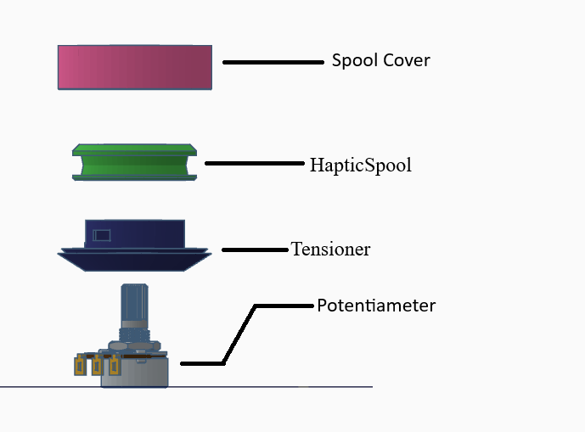

Figure 2: Spool Module Complete

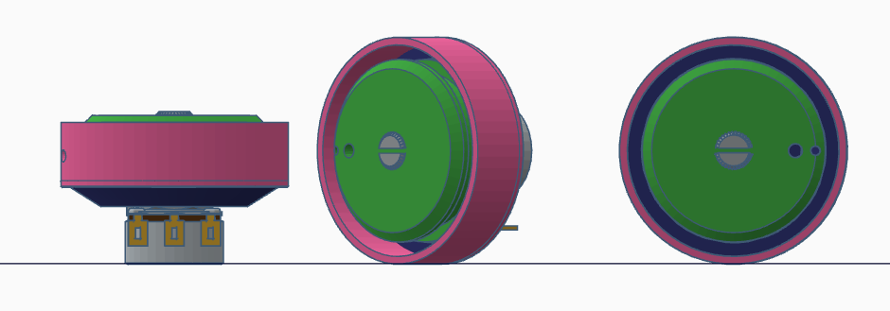

Figure 3: PotHolder Complete

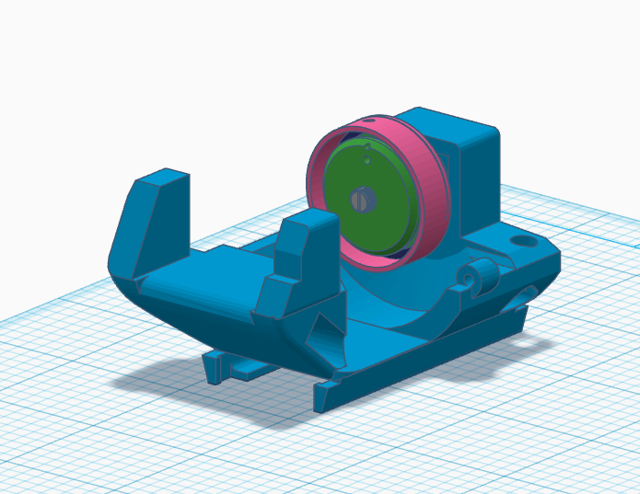

Figure 4: PotHolder Compete - Side

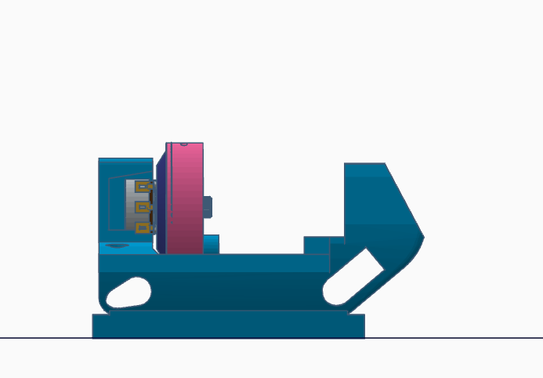

Figure 5: PotHolder Complete- angle

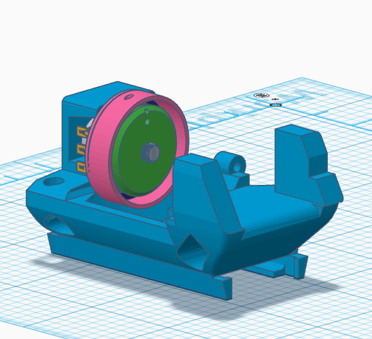

Figure 6: Full Haptic Module

# Appendix B: Final Glove Picture

Figure : Final Glove Picture

